Introduction
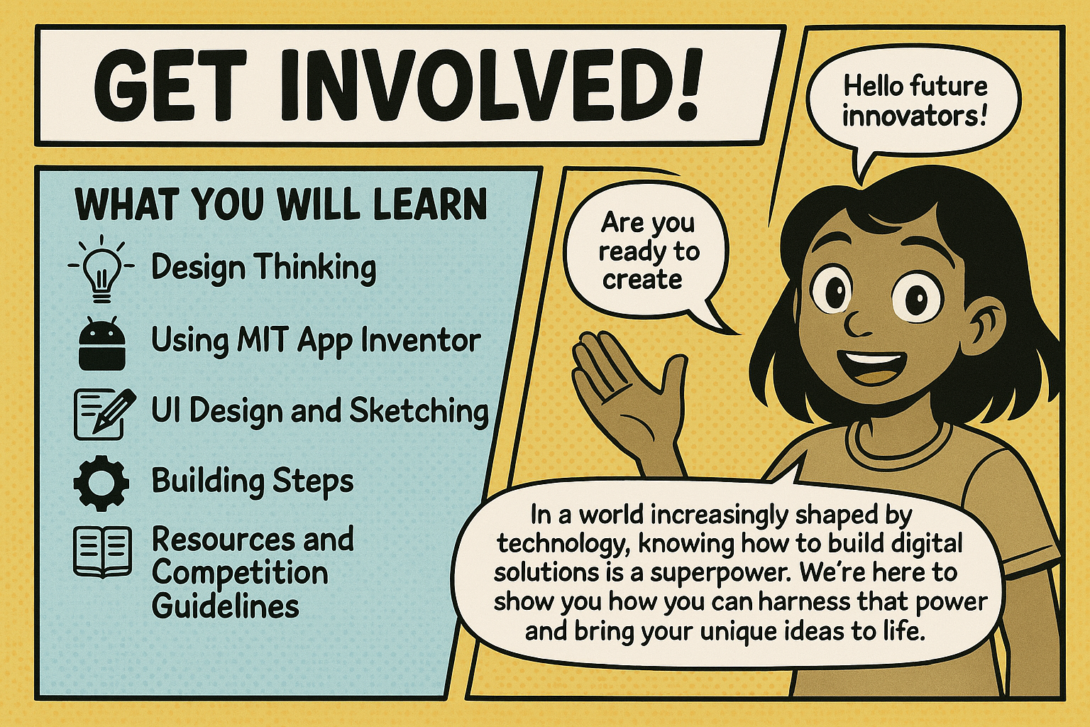

Are you ready to create something amazing? This handbook is your personal guide to building your very own mobile applications, even if you've never written a single line of code before! Get ready to embark on an exciting journey of creativity, innovation, and problem-solving.

Section 1: Design Thinking – Solving Problems Creatively
What is Design Thinking?
Imagine you want to help your community, or simply make daily life easier for people. How do you come up with an idea that truly makes a difference? That's where Design Thinking comes in! It's a powerful, people-focused approach to creative problem-solving. It's all about deeply understanding the people you're designing for and then finding innovative, practical, and effective solutions to their needs.
Think of it as a superpower that helps you understand challenges from different angles and come up with solutions that truly matter.

Design Thinking: Your Superpower for Solving Problems
Ever wanted to invent something cool, make life easier for your friends, or help out in your community? Design thinking is like having a superpower for doing just that! It's a fantastic way to solve problems in a creative and smart way, and guess what? It's all about putting people first.
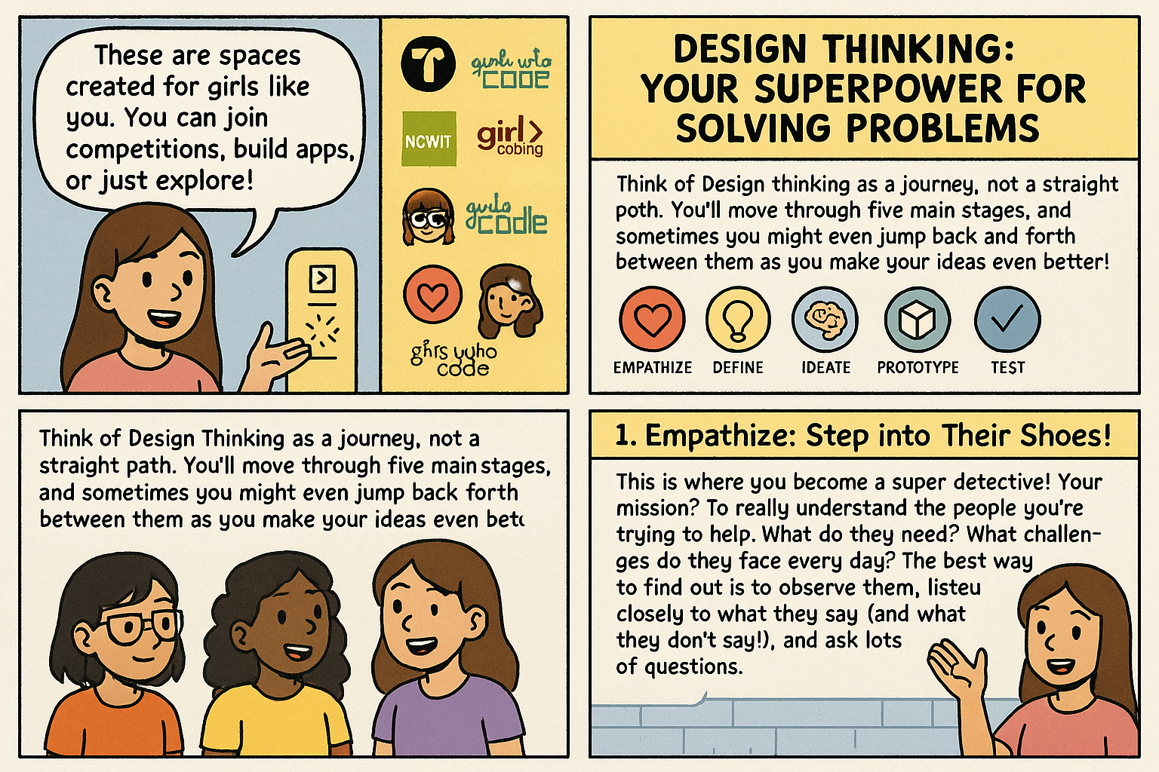

2. Define: What's the Real Problem?
Once you've gathered all your clues, it's time to figure out the exact problem you're trying to fix. Don't just pick the first thing you see; dig deeper to find the root cause. Your goal is to write down a clear, specific problem statement that focuses on the person experiencing the problem.

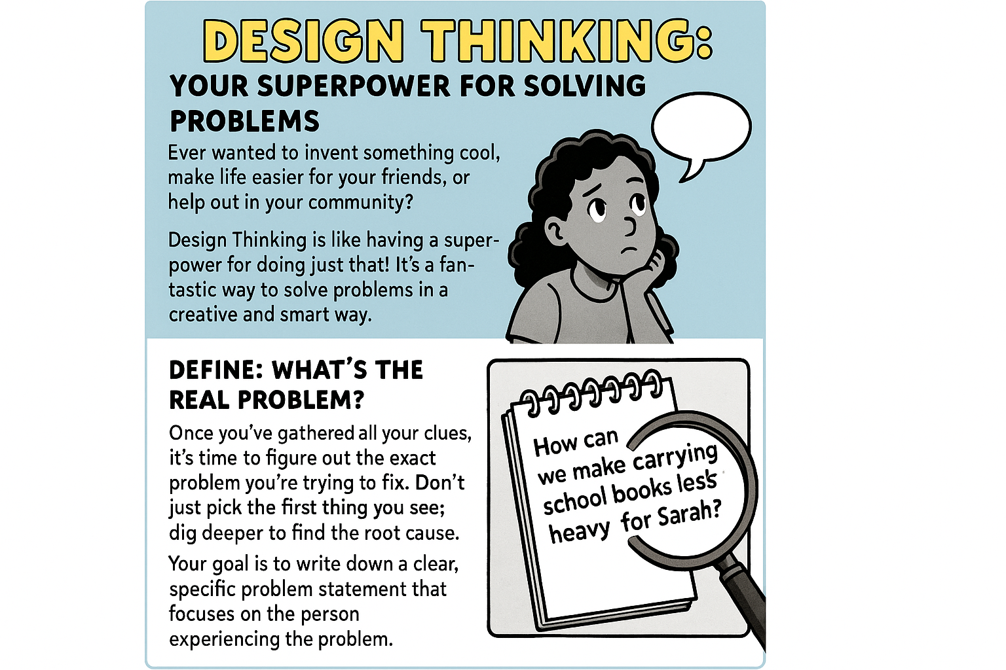

3. Ideate: Let the Ideas Flow
Now for the fun part: brainstorming. This is where you come up with as many possible solutions as you can. No idea is too crazy, too silly, or too impossible at this stage. Think outside the box. The more ideas, the better, even if some seem wild at first. You can do this alone or with your friends - more brains, more ideas.
Imagine: A bunch of colorful lightbulbs popping up everywhere, showing a shower of awesome ideas!

4. Prototype: Bring Your Idea to Life (Simply)
Time to make your best ideas real, but keep it simple! Create a basic, low-cost, scaled-down version of your solution. This could be anything from a quick drawing on paper, a little model made from craft supplies, or even just sketches of what an app screen might look like. The main goal is to have something tangible that you can actually show to people.
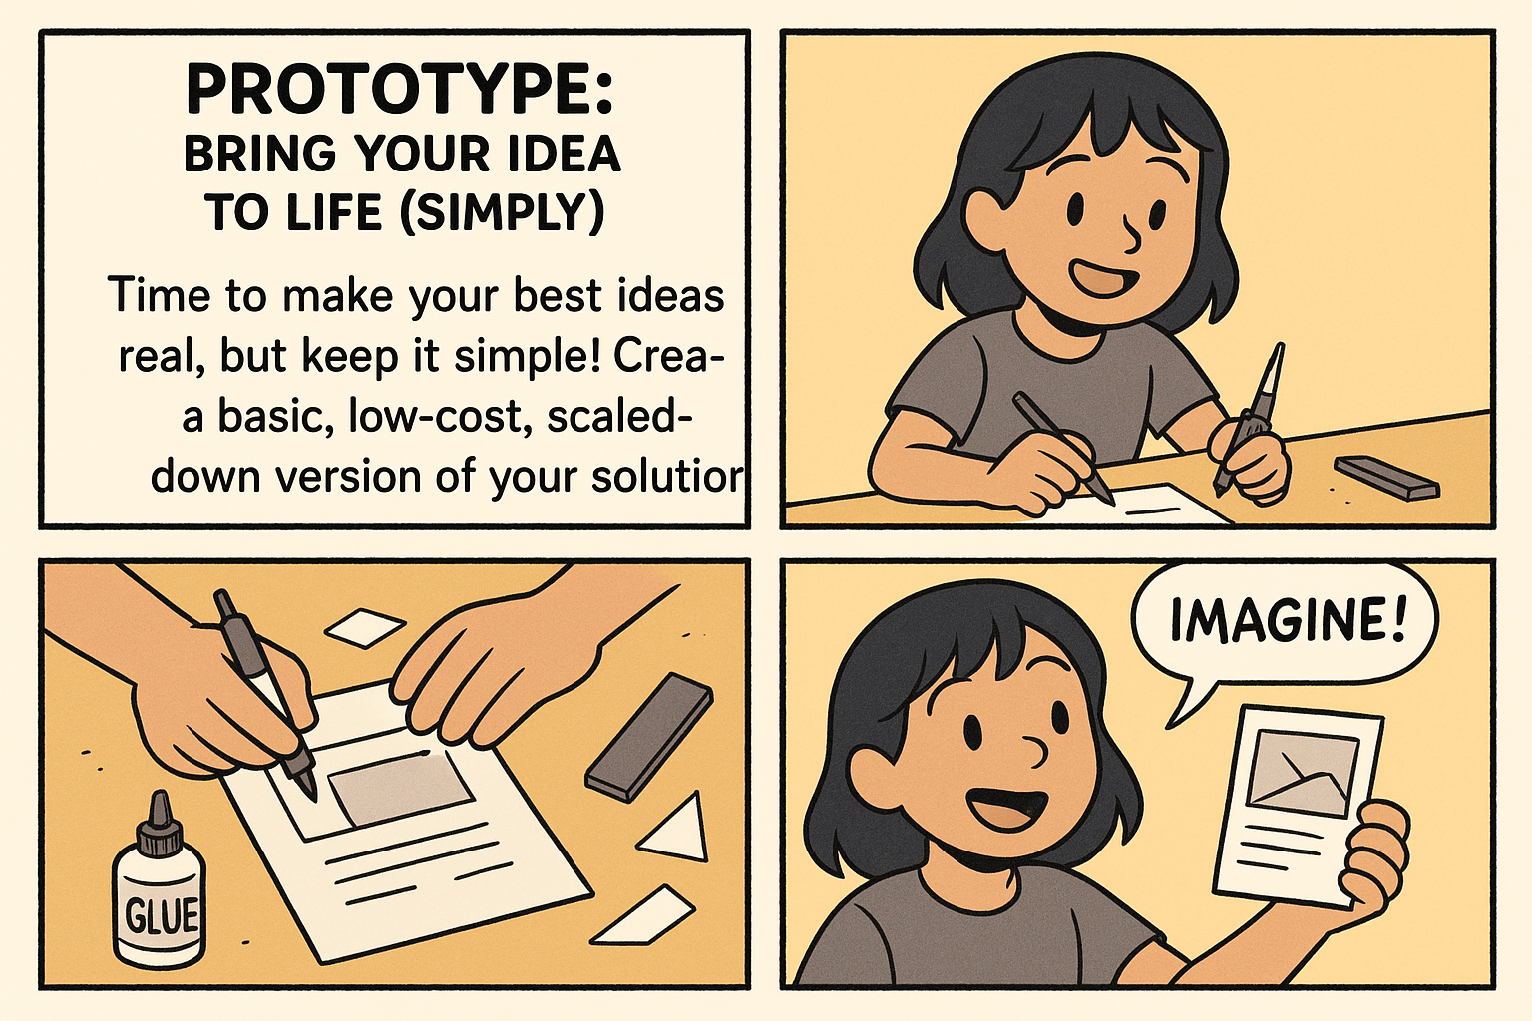

5. Test: Get Real Feedback!
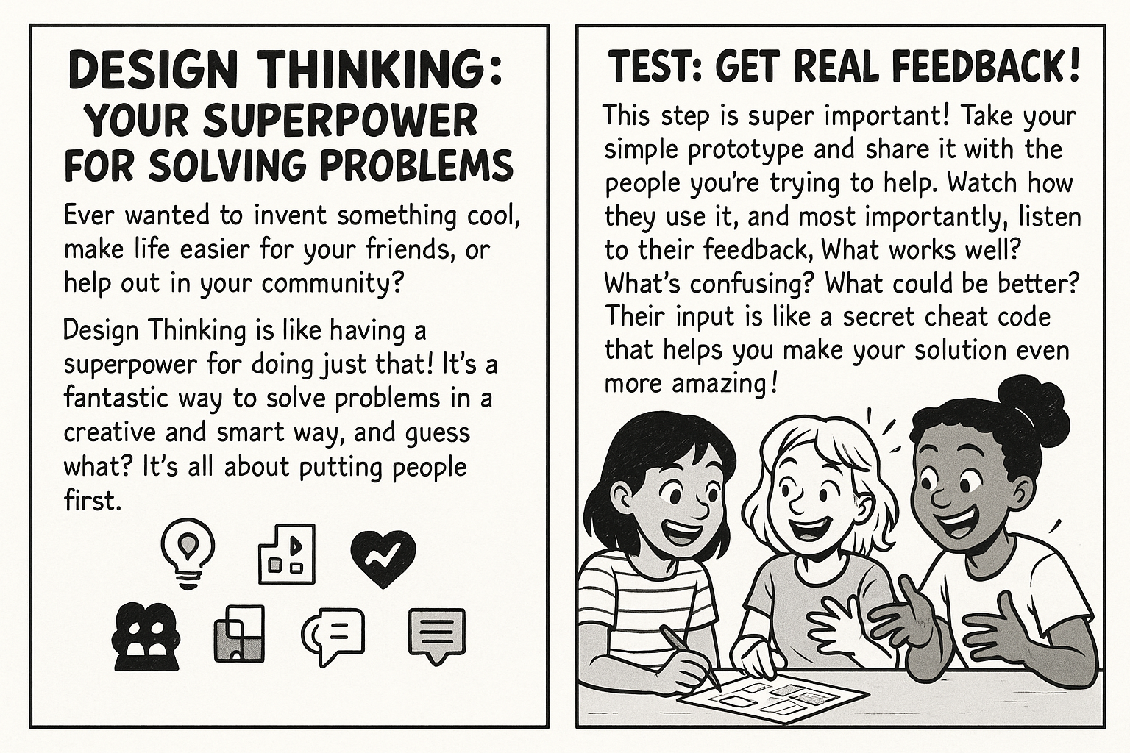
Ready to try out your new design thinking superpower and make a difference? What's one problem you'd love to solve in your community or for your friends?

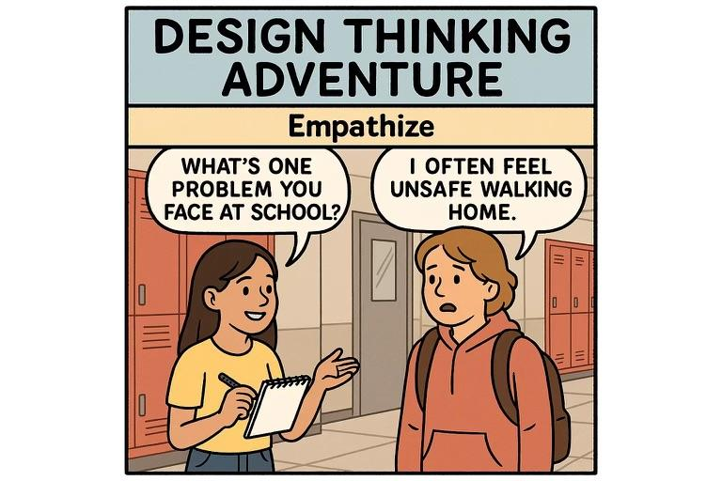

Let's Talk Design Thinking! 🤔
Okay, you've got the basics of design thinking down – awesome. Now, let's really dig in and think about why these steps are so powerful. These questions are perfect for chatting with your friends or just thinking through on your own. Get ready to share your brilliant ideas.

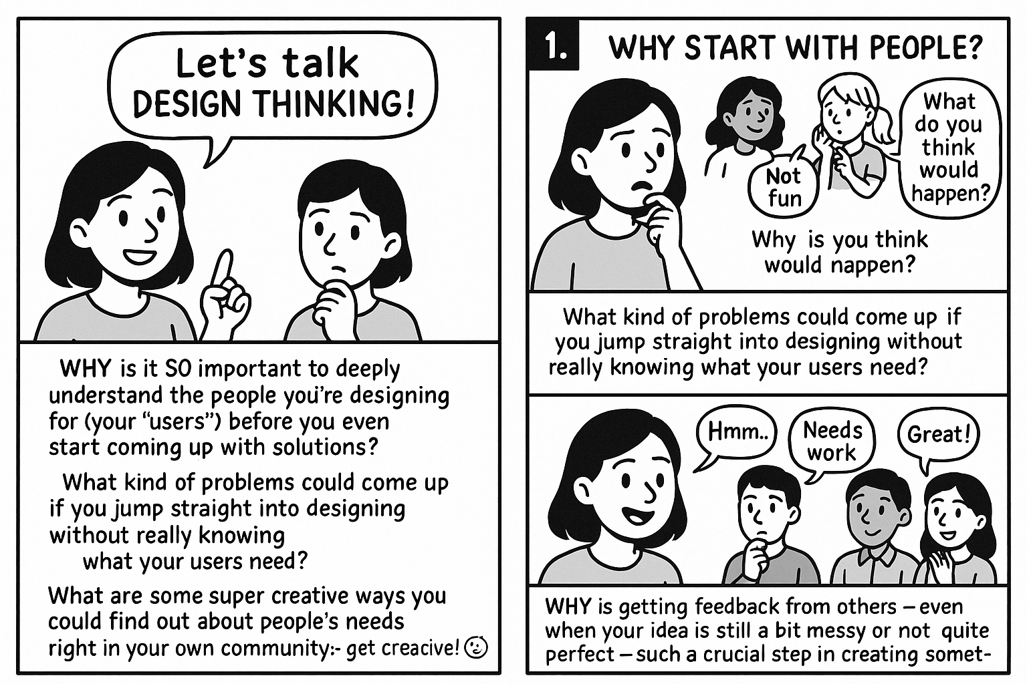

Section 2: Introduction to MIT App Inventor – Your App Building Tool

What is MIT App Inventor?
Imagine building an app by simply dragging and dropping pieces together, like solving a puzzle! That's exactly what MIT App Inventor lets you do. It's a free, web-based platform developed by MIT (Massachusetts Institute of Technology) that empowers anyone to create mobile apps for Android phones or tablets.
Instead of writing complex code, you'll design the look of your app and program its behaviour using visual blocks. It’s intuitive, fun, and incredibly powerful!

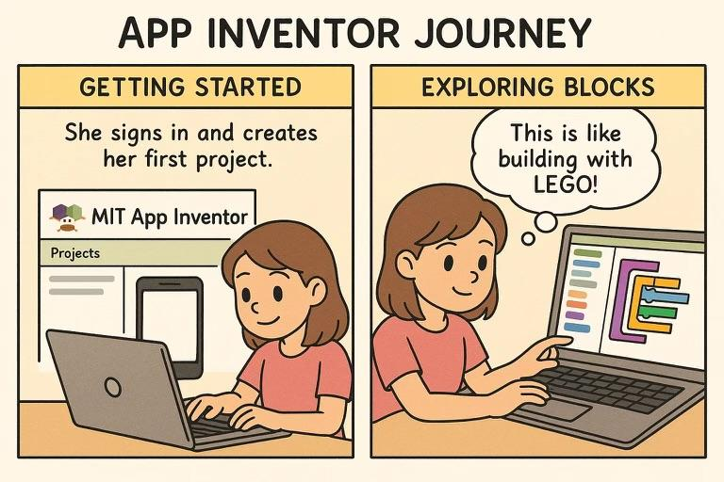

Getting Started with MIT App Inventor
Ready to dive in? Here's how to begin your App Inventor journey:

1️⃣ Open the MIT App Inventor Website
✅ What to do:
- Open your preferred web browser (Chrome is recommended for best compatibility).
- Type https://appinventor.mit.edu in the address bar and press Enter.
- Click on “Create Apps!” in the top right or center of the homepage.
💡 Tip: Bookmark the page for easy access later.
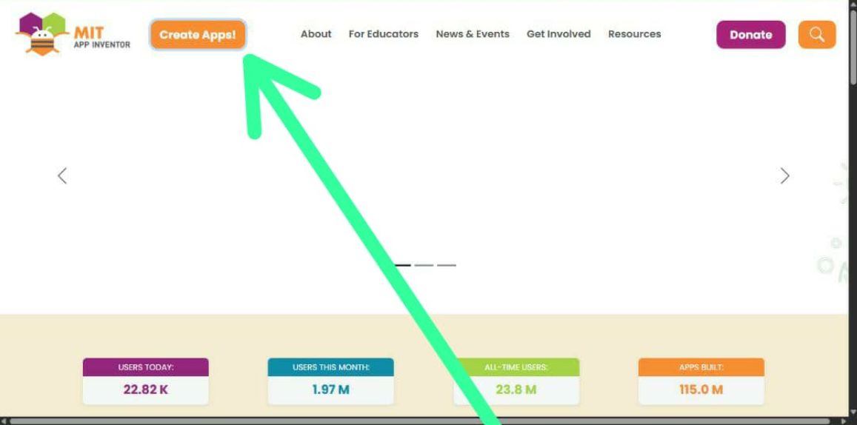

2️⃣ Sign in or Create an Account
✅ What to do:
- Click “Continue” when prompted to log in.
- You’ll usually sign in with a Google account — this is the easiest way.
- If you don’t have a Google account, create one first at accounts.google.com.
- Allow any permissions requested by MIT App Inventor.
💡 Tip: Use the same Google account every time so your projects stay saved.
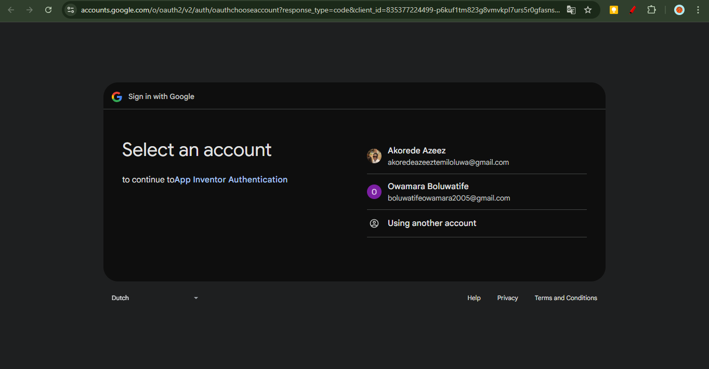

3️⃣ Start a New Project
✅ What to do:
- Once signed in, you’ll land on the Projects dashboard.
- Click “Start new project” (top left).
- Enter a clear, simple name for your app. Example: MyFirstApp.
  - Important: Project names cannot have spaces — use underscores or capitalize words instead.
💡 Tip: Pick a name that describes your app’s purpose to stay organized later.
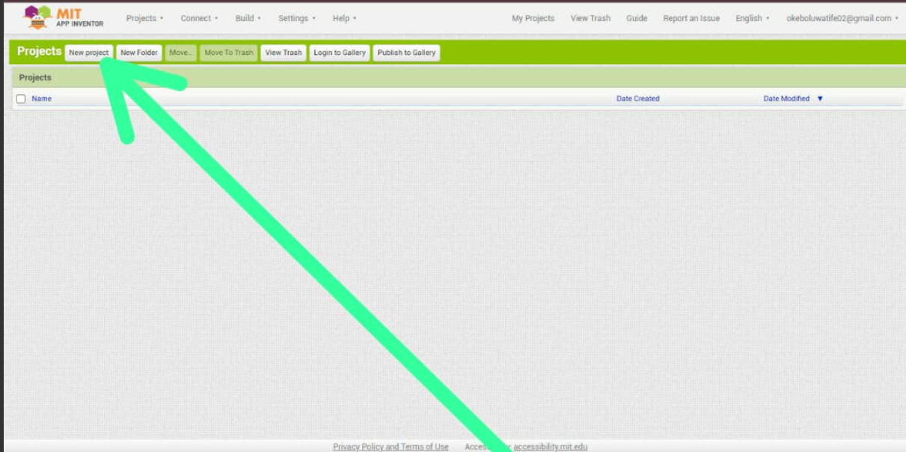

4️⃣ Understand the Designer Screen
✅ What to do:
- You’ll see your new project open in the Designer tab by default.
- The Designer screen has three main parts:
  - Palette (left): Contains components you can drag onto your app.
  - Viewer (center): Shows what your app will look like on a phone.
  - Components & Properties (right): Lets you rename items and set how they look/behave.
✅ Add Components:
- Drag a Button from the Palette onto the Viewer.
- Drag a Label to display text.
- Drag a TextBox for user input.
💡 Tip: Rename each component meaningfully — for example, rename Button1 to SubmitButton.
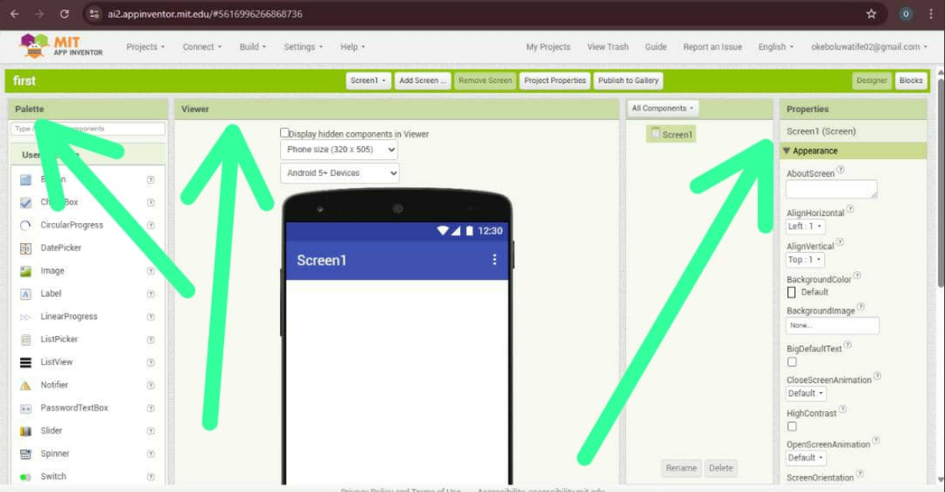

5️⃣ Adjust Component Properties
✅ What to do:
- Click any component in the Viewer.
- In the Properties panel on the right, you can:
  - Change the text (e.g., change Button to Click Me!).
  - Pick colors, fonts, sizes.
  - Set alignment, width, height.
💡 Tip: Preview changes immediately — they appear on the Viewer in real time.
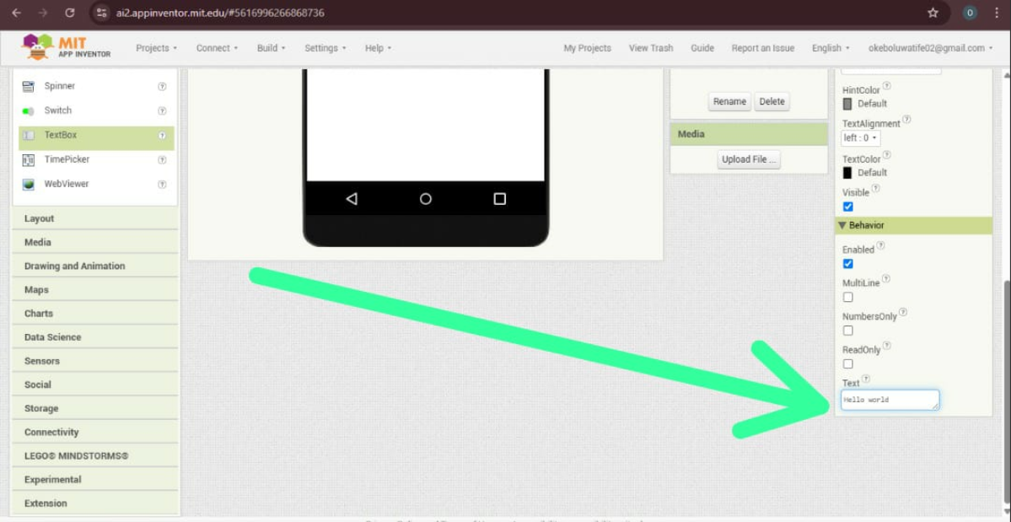

6️⃣ Add Functionality with the Blocks Editor
✅ What to do:
- Click the Blocks tab (top right).
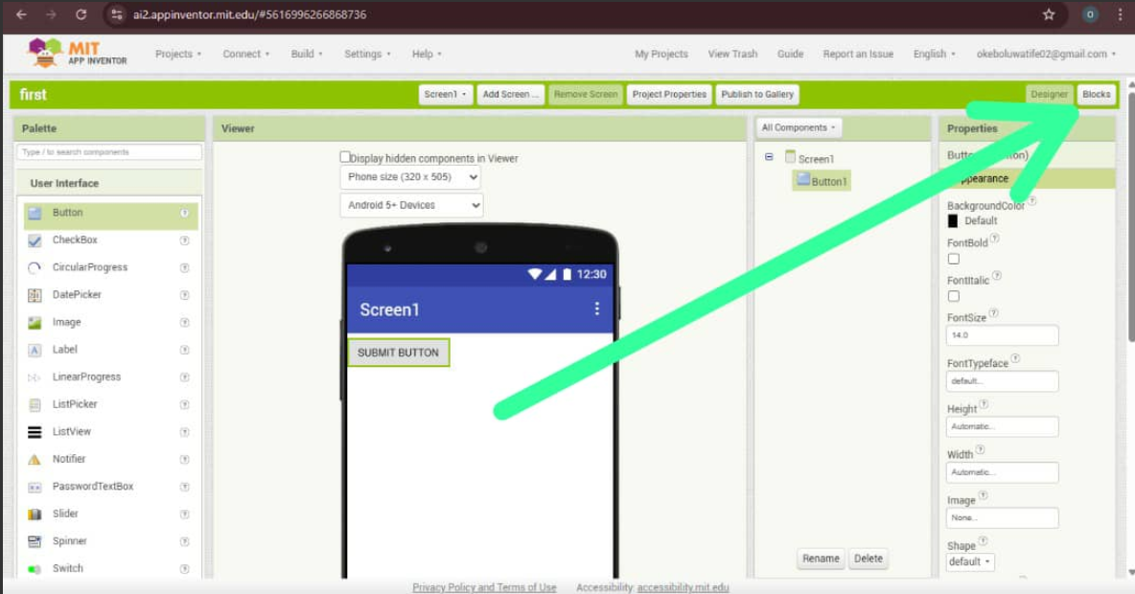
- On the left, you’ll see drawers for each component you added.

- Click a component’s drawer to see its blocks.
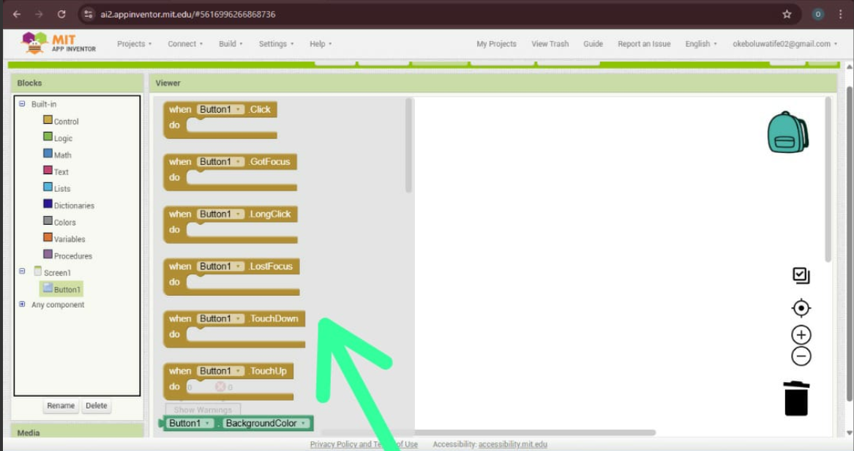
- Drag blocks onto the workspace to define behavior.
  - Example: Drag when Button.Click and connect it to set Label.Text.
✅ How to snap blocks:
- Click and drag them like puzzle pieces — they only fit if they’re compatible.
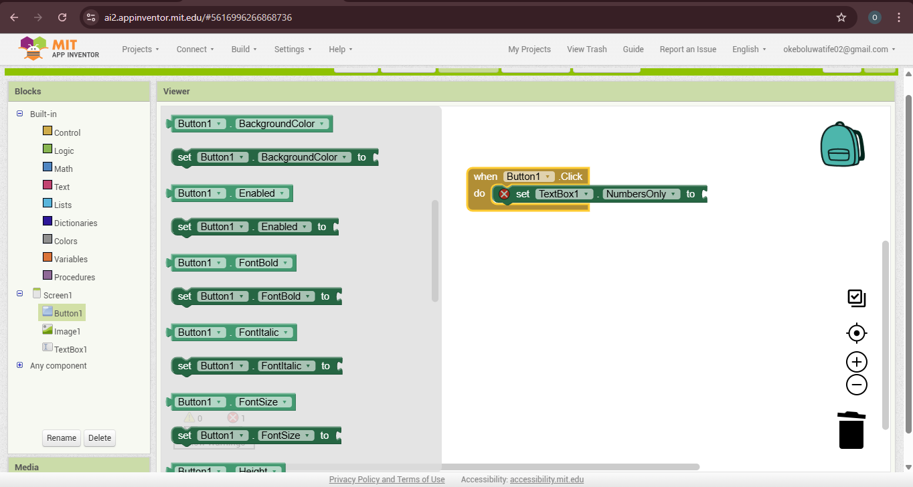
💡 Tip: Use Control, Math, and Logic drawers for more advanced behaviors.

7️⃣ Test Your App on a Real Device
✅ Option 1: Use the AI2 Companion App (recommended)
- Install MIT AI2 Companion from the Google Play Store.
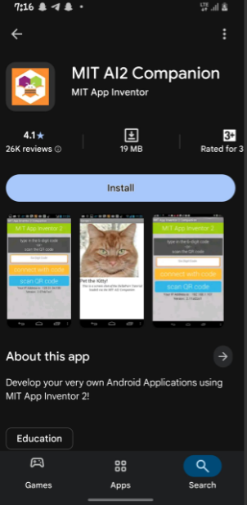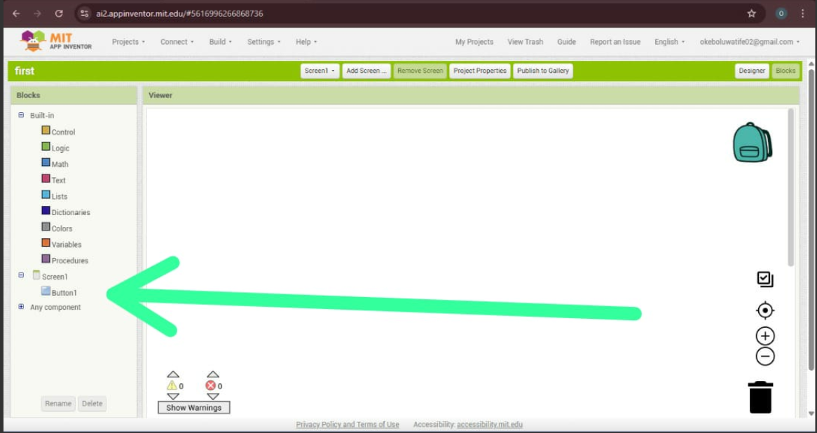
- In App Inventor, click “Connect” → “AI Companion”.
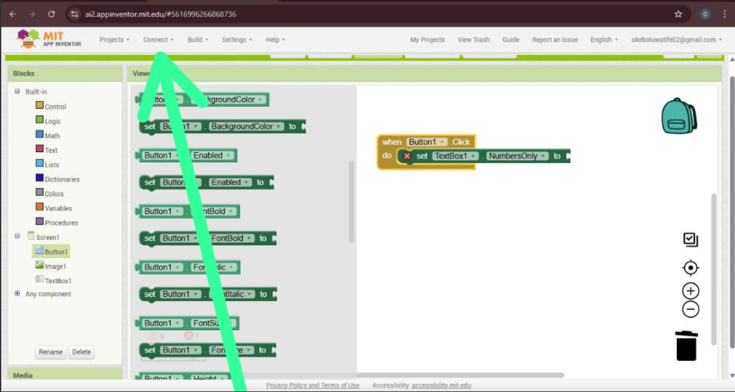
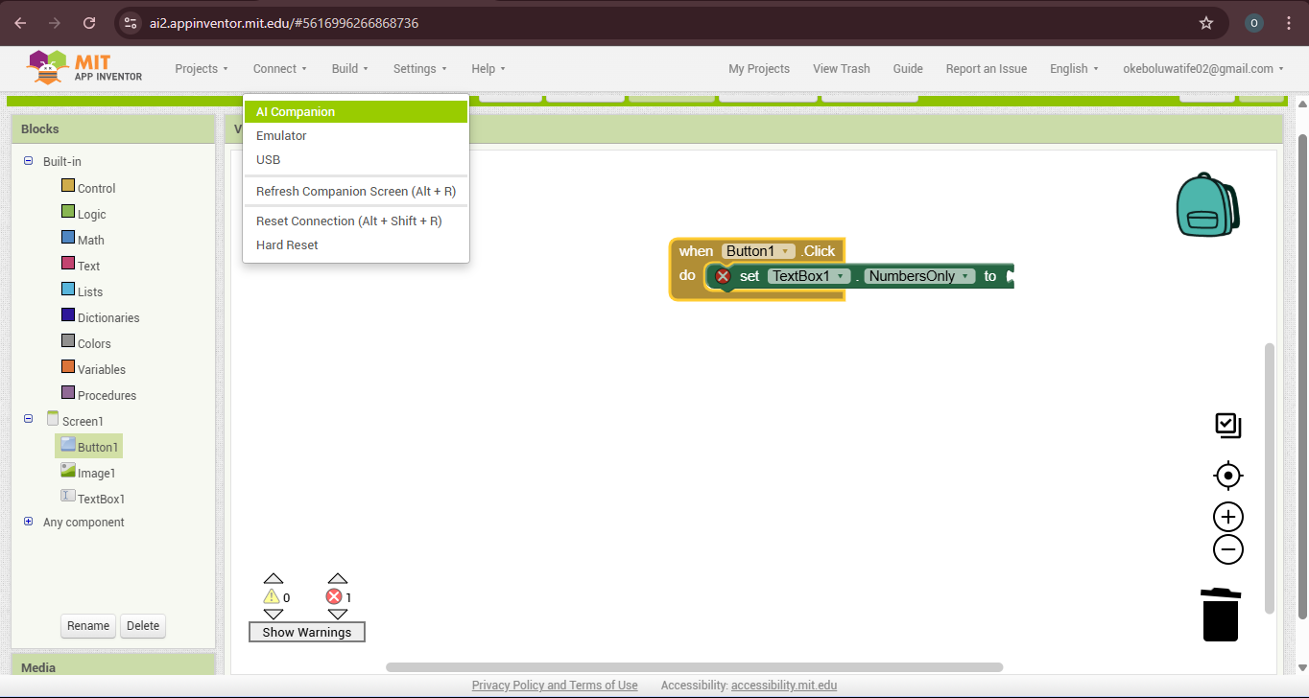
- Scan the QR code with the Companion app — your app runs live on your phone!
✅ Option 2: Build an APK (for full install)
- Click “Build” → “App (provide QR code for .apk)”.
- Scan the generated QR code — download the .apk file and install it.
💡 Tip: Keep your phone and computer on the same Wi-Fi network for live testing.

8️⃣ Save and Export Your Work
✅ What to do:
- MIT App Inventor auto-saves, but you can click “Projects → Save project” for peace of mind.
- To download a backup, click “Projects → Export selected project (.aia) to my computer.”
- Save the .aia file safely — you can re-import it anytime.
💡 Tip: Back up often if you’re trying complex features.
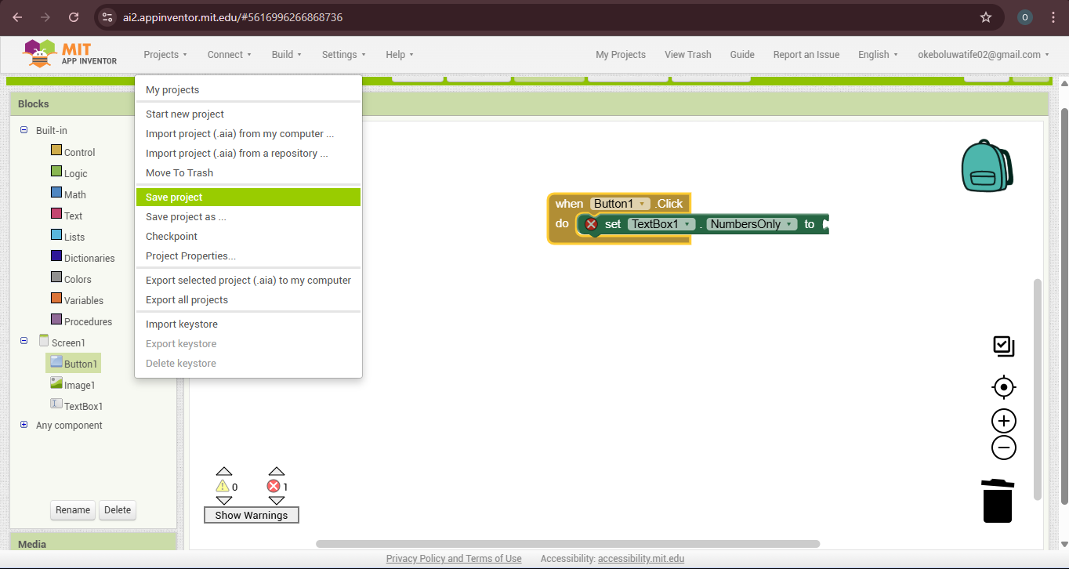

9️⃣ Keep Learning & Improving
✅ Next steps:
- Experiment with more components (e.g., sensors, media).
- Try tutorials from MIT App Inventor’s “Resources” page.
- Watch YouTube videos or join the App Inventor Community for ideas and help.
💡 Tip: Start small. Build fun mini apps — like a calculator, quiz, or simple game — to build your skill

✅ You Did It!
With these detailed steps, you’re ready to design, code, and test your own Android apps with MIT App Inventor — no prior coding experience needed!

Key Components of App Inventor
When you're in App Inventor, you'll primarily work with two main views and lots of components:
- Designer View: This is your visual space. It's where you design the look and feel of your app. You'll drag and drop user interface elements like buttons, images, text boxes, and more onto your app screen. What you see here is what your app will look like.
  - Illustration idea: A clear screenshot of the Designer View, highlighting the Palette, Viewer, Components, and Properties sections.

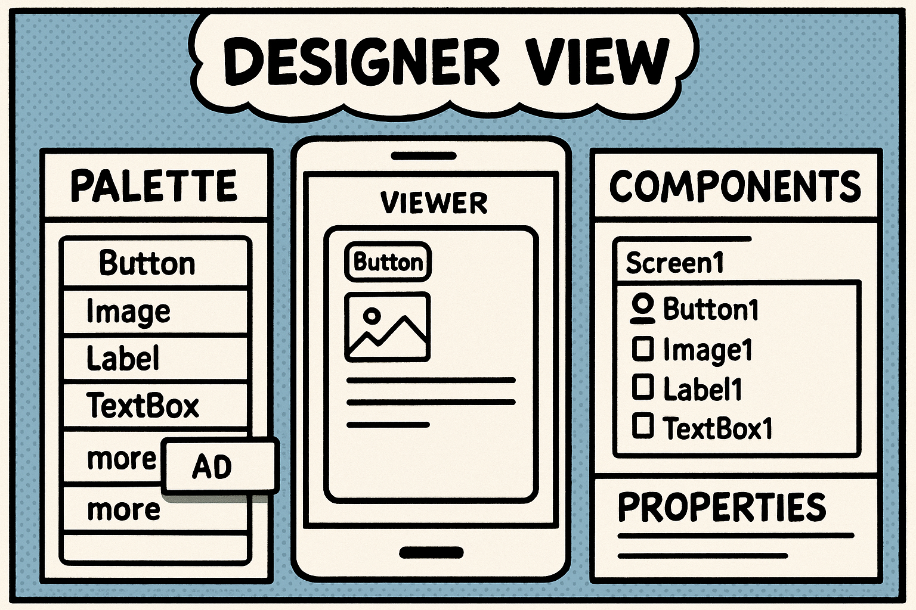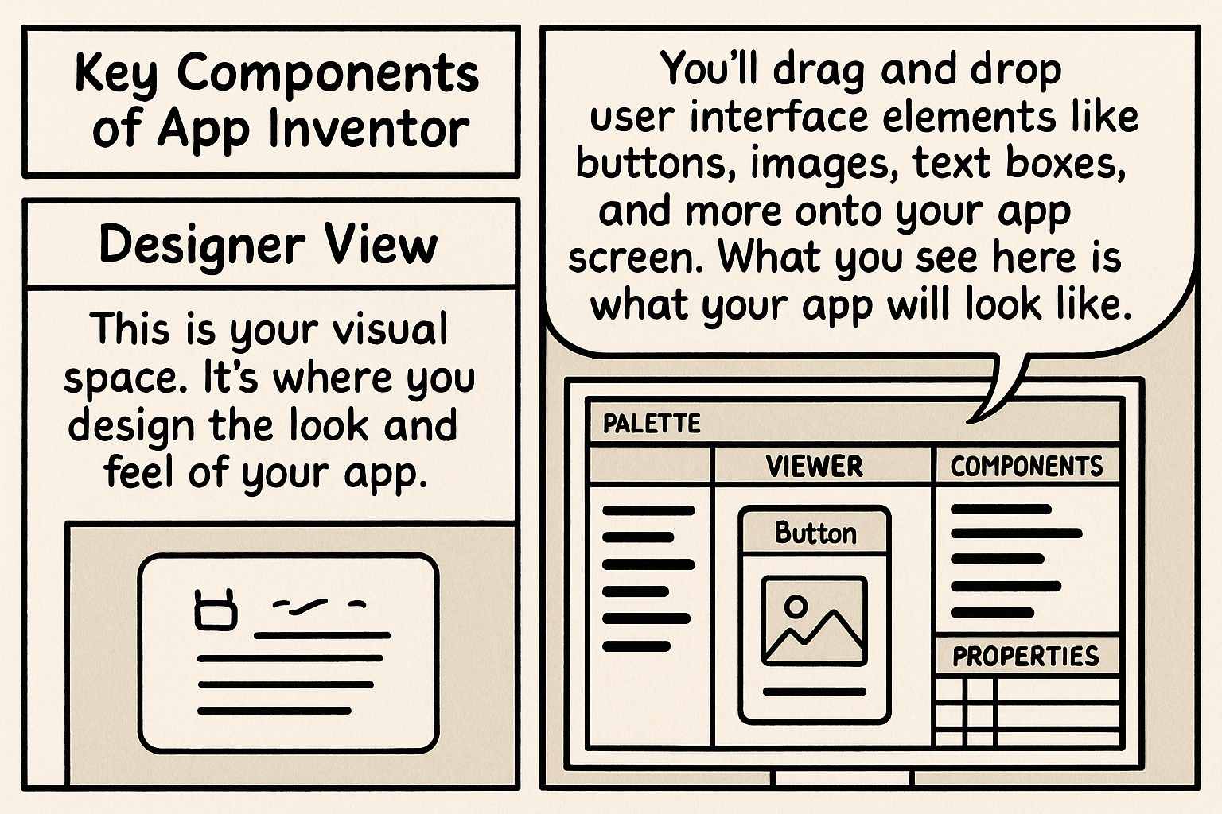

- Blocks View: This is where the magic happens. It's where you program your app's behavior and logic using colorful, interlocking blocks. Instead of writing code, you'll snap these blocks together like Lego pieces to tell your app what to do when a button is clicked, or when a user types something.
  - Illustration idea: A clear screenshot of the Blocks View, showing some basic blocks connected (e.g., a button click event leading to changing text).
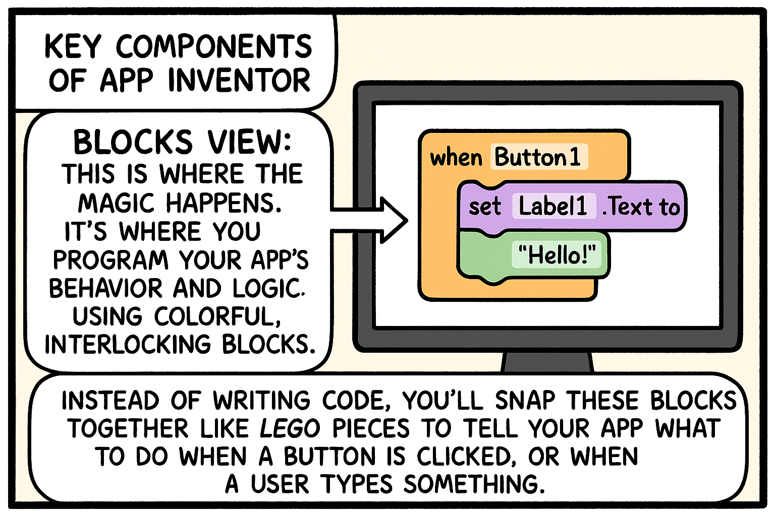
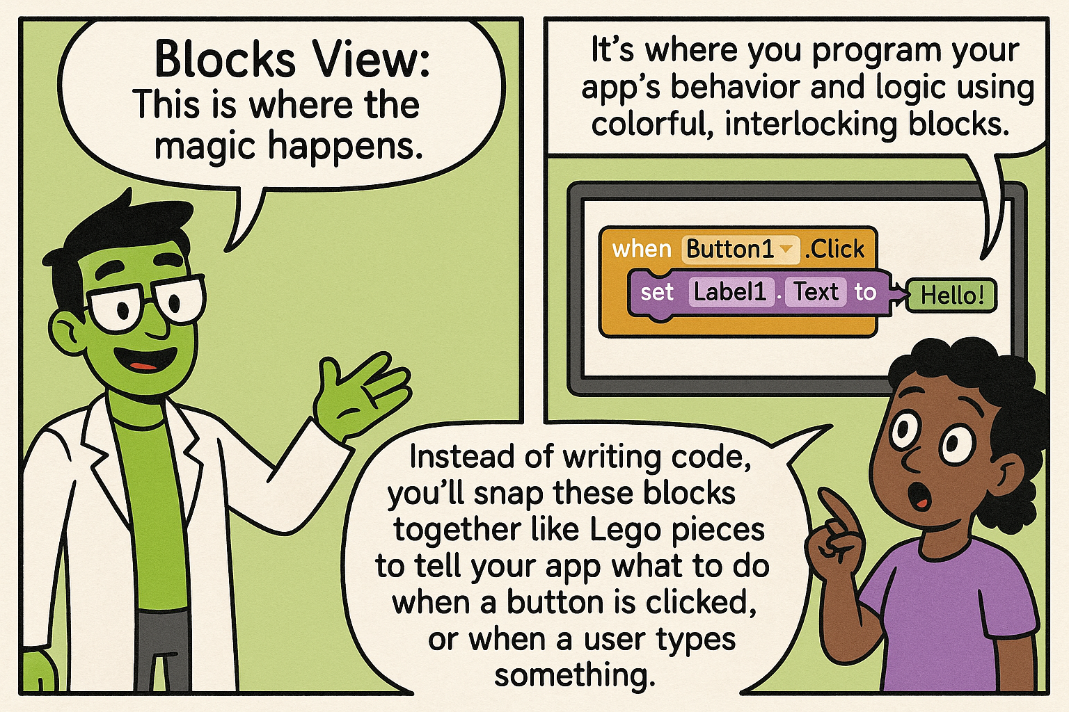
- Components: These are the fundamental building blocks for your app. Think of them as the ingredients. They include things like:
  - User Interface components: Buttons, Labels (for text), TextBoxes (for input), Images, Checkboxes, etc.
  - Media components: Sound, VideoPlayer, Camera.
  - Sensors: Accelerometer (for phone movement), LocationSensor.
  - And many more! Each component has its own properties (like color, size, text) and events (like being clicked).
Illustration idea: A small collage of icons representing different components like a button, a text box, and a sound icon.

Section 3: UI Design and Sketching – Making Your App Shine

What is User Interface (UI) Design?
Think about your favourite apps. What makes them great? It's not just what they do, but also how they look and how easy they are to use. That's UI (User Interface) Design. It's all about making your app easy, intuitive, and enjoyable for users to interact with. It focuses on:
- Visual appeal: Colours, fonts, images, and overall layout.
- Layout and navigation: Where things are placed and how users move between different parts of your app.
- Usability: Is it clear what a button does? Can users easily find what they're looking for?
Good UI design makes users happy and keeps them coming back.
Why Sketching is Important
Before you even touch App Inventor, grab a pen and paper. Sketching helps you plan your app before you start building it digitally. It’s like creating a blueprint for a house.
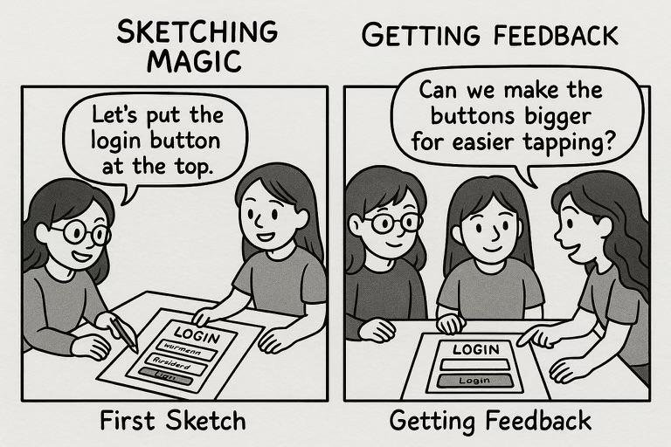
Why is it so powerful?
- Explore ideas quickly: You can draw many different layouts in minutes, without getting burdened by technology.
- Visualize user flow: How will users move from one screen to another? Sketching helps you map this out.
- Identify problems early: It’s much easier to erase a line on paper than to rearrange complex components in App Inventor.
- Get feedback easily: Show your sketches to friends and get their initial thoughts before you invest time building.

Tips for Sketching Your App
Here are some simple tips to make your app sketching effective:
- Start with simple shapes: Use rectangles for screens, circles for buttons, and lines for text. Don't worry about artistic perfection.
- Label each part of your sketch: Write down what each button does, what text will appear, and where an image will go. This makes your ideas clear.
- Think about user navigation: How will users move from the home screen to other sections? Draw arrows to show the flow between screens.
- Get feedback from others: Share your sketches with friends, family, or mentors. Ask them: Is this easy to understand? What would you expect to happen here?

Section 4: Steps for Building Your App – From Idea to Reality
Now that you understand design thinking and the basics of App Inventor and UI sketching, let's put it all together. Here are the practical steps to build your amazing app.

Step 1: Define Your App Idea (Empathize & Define)
This is where you apply your design thinking skills.
- What problem are you trying to solve? Be specific. Is it about helping students learn better, connecting community members, or something else?
- Who is your target audience? Who will use this app? Understanding them will guide all your design choices.
- What core features will your app have? Don't try to do everything at once. Focus on the most important functions that solve your defined problem.

Step 2: Sketch Your App Design (Ideate & Prototype)
Grab your notebook and pencil.
- Create a rough sketch for each main screen in your app. Think about every screen a user will see.
- Plan the layout and placement of components on each screen. Where will the buttons go? Where will the text be displayed? What images will you use?
- Draw arrows to show how users will move from one screen to another.

Step 3: Build the UI in App Inventor (Prototype)
Time to bring your sketches to life in the digital world.
- Open App Inventor and start a new project.
- Use the Designer View to add components (buttons, labels, images, text boxes, etc.) to each screen of your app.
- Arrange the components according to your sketches. Pay attention to their size, position, and alignment.
- Adjust component properties (like text, color, font size) in the Properties panel to match your desired look.

Step 4: Program the App Logic (Prototype & Test)
This is where you make your app interactive.
- Switch to the Blocks View.
- Use the Blocks to add functionality to your app. Think about what should happen when a user interacts with a component. For example:
  - "When Button1 is clicked, set Label1's text to 'Hello!'"
  - "When Screen1 initializes, play Sound1."
- Connect blocks together like puzzle pieces to create the desired behaviour for your app. Don't be afraid to experiment.

Step 5: Test Your App (Test)
Testing is crucial for finding and fixing problems.
- Connect your phone or tablet to App Inventor for live testing. You can do this using the AI Companion app (download it from the Play Store) or by connecting via USB. This allows you to see your changes instantly on your device.
- Thoroughly test every part of your app. Click every button, type in every text box, and try to break it.
- Ask others to test your app and give feedback. Their fresh perspective will help you find issues you missed and give you ideas for improvement.
- Repeat based on feedback, go back to previous steps (sketching, UI building, programming) to make improvements. This repetitive process is a core part of Design Thinking.

Checklist for Building Your App
Use this checklist to ensure you've covered all the essential steps.
- Define the app idea clearly.
- Sketch the app design for all screens.
- Build the UI in App Inventor (all components added and arranged).
- Program the app logic (all interactive features work as intended).
- Test the app thoroughly on a real device.
- Gather feedback and make improvements.

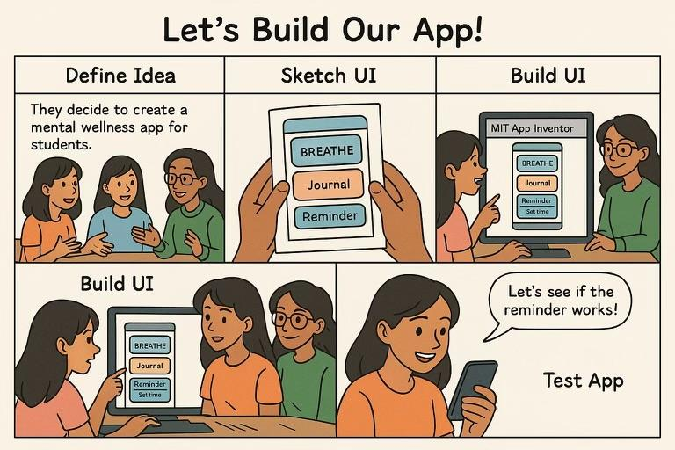

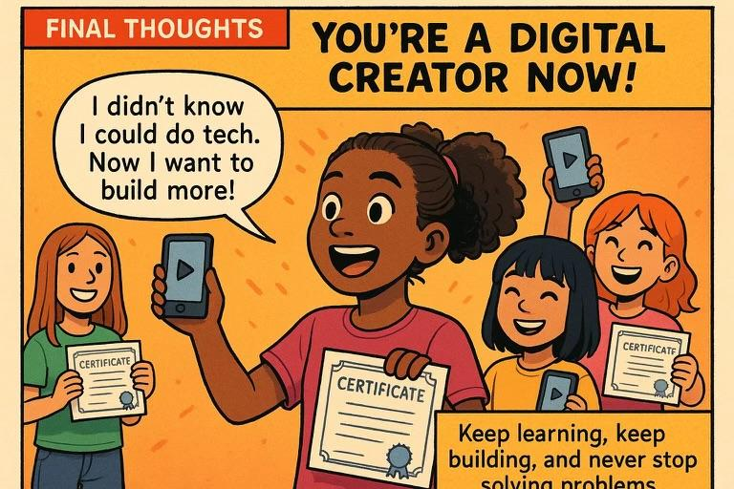

Section 5: Additional Resources – Keep Learning

Websites
- MIT App Inventor Official Website: appinventor.mit.edu
- App Inventor Tutorials: Look for sections dedicated to "Tutorials" on the official website. They offer step-by-step guides for building various types of apps.

Videos

Books
- https://ai2.appinventor.mit.edu/reference/blocks/

Section 6: Competition Guidelines
This handbook isn't just about learning; it's about empowering you to create and showcase your talent. We're excited to invite you to participate in our mobile app development competition.

Eligibility
- Must be a secondary school girl aged 13-19 in Nigeria.
- Participants must be computer literate

Theme: Digital Science Combined with Arts & Design
Description:
This competition invites students to develop a simple, and interactive mobile app using MIT App Inventor, a no-code platform, to solve problems in any of the three key areas: agriculture, health, and the environment.

Learning Outcomes:
These are the specific skills and knowledge students should gain from participating in this project. They cover both the "Digital Science" (computational thinking, problem-solving) and "Arts & Design" (creativity, user-centered design) aspects.
- Computational Thinking & Programming:
  - Apply computational thinking principles (decomposition, pattern recognition, abstraction, algorithms) to break down a real-world problem.
  - Develop basic programming logic using block-based coding in MIT App Inventor.
  - Understand and implement event-driven programming (e.g., what happens when a button is clicked).
  - Debug and troubleshoot their app to identify and fix errors.
  - Understand the basics of data input, processing, and output in an app.
- Problem-Solving & Innovation:
  - Identify a specific, real-world problem within agriculture, health, or the environment.
  - Brainstorm and conceptualize a mobile app solution to address that problem.
  - Demonstrate creativity and innovation in their app's features and design.
  - Iterate on their app design and functionality based on feedback and testing.
- Design Thinking & User Experience:
  - Apply user-centered design principles to create an app that is intuitive, easy to use, and meets the needs of its target audience.
  - Develop visual communication skills through effective UI design (layout, color, typography, iconography).
  - Understand the importance of aesthetics in engaging users and conveying information effectively.
  - Create visually appealing and functional mock-ups/prototypes using App Inventor's design interface.
- Domain Knowledge & Research:
  - Gain a deeper understanding of a chosen problem within agriculture, health, or the environment.
  - Conduct basic research to inform their problem definition and solution design.
  - Understand how technology can be applied to solve real-world challenges in these thematic areas.
- Communication & Presentation:
  - Clearly articulate their app idea, the problem it solves, and its features.
  - Develop skills in presenting their project (e.g., through a pitch deck or demonstration).
  - Effectively communicate design choices and technical functionality.

Student Task Framework and Learning Outcomes (What Should Be Achieved with the Training & Competition)
Overall Goal:
Equip students with practical digital skills to imagine and build creative solutions to real-world problems using accessible digital tools, design thinking, and basic AI/no-code platforms.
Outcomes:
- Digital Awareness – Understand the role of digital tools, AI, and design in solving everyday problems.
- Problem-Solving – Learn to identify problems and ideate relevant solutions using tech.
- Prototyping Skills – Gain hands-on experience creating a basic digital product
- Teamwork & Communication – Collaborate and present solutions with clarity and creativity.
- Presentation & Advocacy – Showcase projects confidently to judges using digital slides or demos.
Breakdown of Tasks for Students
Each student/team will follow these tasks during the training and competition. It can be adapted to fit a one-week bootcamp or a multi-week programme.
Phase 1: Ideation & Problem Framing
Objective: Pick a theme and define a problem to solve
Tasks:
● Choose one of the competition themes:
a. Digital Invention
b. Digital Science + Arts/Design

● Identify a real-world problem you want to solve (e.g., waste management in school, poor recycling habits, learning difficulties, energy use, food production etc.)
● Complete a simple problem definition worksheet (who it affects, why it matters)
Phase 2: Research & Design Thinking
Objective: Develop the solution idea and plan how to build it
Tasks:
● Brainstorm and sketch out your solution (Mobile App)
● Aquint yourself with the MIT App inventor
● Create a basic storyboard or UI layout (using paper or Canva or Figma)
Phase 3: Digital Skills Training & Prototyping
Objective: Learn the tools and start building the actual solution
Tasks:
● Attend digital tool tutorials
● Begin prototyping your idea which could be an app, a game, a chatbot or AI tool
● Test the project and improve the user experience
Phase 4: Presentation & Submission
Objective: Finalise and present the solution to judges
Tasks:
● Prepare your final submission pack, which includes:
○ A short project pitch deck (in Google Slides or Canva)
○ A working prototype or video walkthrough
○ A brief team reflection: What you learned, what you’d improve
● Present to the judges (live or via a recorded pitch)

Submission Requirements
To ensure your entry is complete and properly assessed, please submit the following:
- App file (.apk): This is the actual installable file of your app. Instructions on how to generate this from App Inventor will be provided by your instructors.
- Project Description Document (PDF): A maximum of 2 pages, outlining:
  - App Title and your name/team name.
  - The problem your app solves (refer back to Design Thinking).
  - Your target audience.
  - Key features of your app.
  - How did you use design thinking in your app development process.
  - Any unique or innovative aspects of your app.
Presentation :
  - A live presentation (details will be shared closer to the event).
  - A pitch deck demonstrating your app and explaining its features

Judging Criteria
Your apps will be evaluated based on the following:
- Innovation (25%): How creative and original is your app idea? Does it offer a unique solution to a problem?
- User Interface (UI) and Experience (UX) (25%): Is your app visually appealing and easy to use? Is the navigation easy to use? (Think about your UI Design and Sketching skills)
- Functionality (25%): Does the app work as intended? Are there any bugs or crashes? Do all the features perform correctly?
- Impact (25%): What potential impact does your app have? Does it address a real-world problem effectively? Can it make a positive difference in your community or beyond?

Timeline
Mark these important dates on your calendar
- Competition Start Date:
- Workshop/Training Session:
- Submission Deadline:
- Judging Period:
- Winners Announcement & Award Ceremony:

Prizes
We believe in celebrating talent and hard work. Amazing prizes await the top app creators:
- 1st Place:
- 2nd Place:
- 3rd Place:
- All Finalists:

Conclusion: Your Journey Has Just Begun

Final Thoughts
Congratulations on making it through this handbook. You now have the fundamental knowledge and tools to bring your app ideas to life. Remember these key takeaways as you continue your journey:
- Don't be afraid to experiment. The best way to learn is by doing, trying new things, and not being scared of making mistakes. Every challenge is a learning opportunity.
- Collaboration is key. Share your ideas, get feedback, and even work with others. Two heads are often better than one.
- Celebrate your achievements. Every app you create, every problem you solve, and every new skill you learn is a reason to be proud.
We are incredibly excited to see the innovative solutions you will create. Your ideas have the power to change the world, one app at a time. Go forth and build.

Thank you!

